Virtual Router

🖥️ What is a Virtual Router?
# Source: AI Source: Provided by: [Data Path: Persons Table -> ID Column: 1, Name_En Column: Motasem Essam] -> From: [ChatGPT] on [12/18/2025]
A Virtual Router is a software-based router that performs the same functions as a physical (hardware) router — routing network traffic, managing IP addresses, supporting protocols, etc. — but it runs on a virtual machine (VM) or cloud infrastructure instead of dedicated hardware.

💡 Key Concept:
# Source: AI Source: Provided by: [Data Path: Persons Table -> ID Column: 1, Name_En Column: Motasem Essam] -> From: [ChatGPT] on [12/18/2025]
Instead of using a physical box with ports, a virtual router runs as software on a server or in the cloud, often using virtualization technologies like:
- VMware
- KVM (Kernel-based Virtual Machine)
- Hyper-V
- Containers (Docker, Kubernetes)
- Cloud platforms (AWS, Azure, GCP)

🔧 Key Features of Virtual Routers
# Source: AI Source: Provided by: [Data Path: Persons Table -> ID Column: 1, Name_En Column: Motasem Essam] -> From: [ChatGPT] on [12/18/2025]
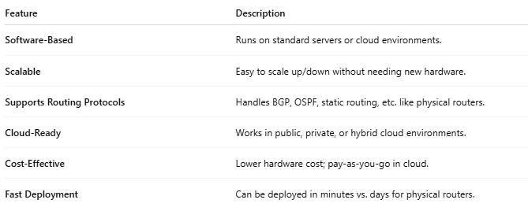

Feature | Description
Software-Based | Runs on standard servers or cloud environments.
Scalable | Easy to scale up/down without needing new hardware.
Supports Routing Protocols | Handles BGP, OSPF, static routing, etc. like physical routers.
Cloud-Ready | Works in public, private, or hybrid cloud environments.
Cost-Effective | Lower hardware cost; pay-as-you-go in cloud.
Fast Deployment | Can be deployed in minutes vs. days for physical routers.

📍 Where Virtual Routers Are Used
# Source: AI Source: Provided by: [Data Path: Persons Table -> ID Column: 1, Name_En Column: Motasem Essam] -> From: [ChatGPT] on [12/18/2025]
- Cloud networks (e.g., AWS VPCs, Azure VNets)
- Software-defined networking (SDN) environments
- Virtual private networks (VPN) infrastructure
- Network function virtualization (NFV) in telecom
- Test labs (safe testing of routing setups without hardware)

🖥️ Example Virtual Router Use
# Source: AI Source: Provided by: [Data Path: Persons Table -> ID Column: 1, Name_En Column: Motasem Essam] -> From: [ChatGPT] on [12/18/2025]
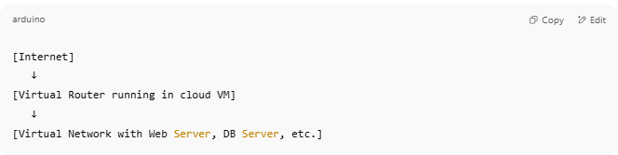

[Internet]
↓
[Virtual Router running in cloud VM]
↓
[Virtual Network with Web Server, DB Server, etc.]

🆚 Physical Router vs Virtual Router
# Source: AI Source: Provided by: [Data Path: Persons Table -> ID Column: 1, Name_En Column: Motasem Essam] -> From: [ChatGPT] on [12/18/2025]
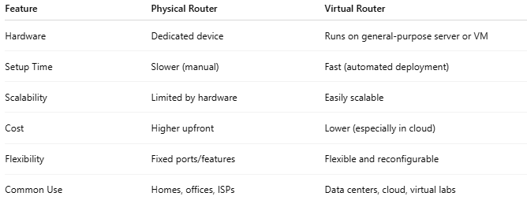

Feature | Physical Router | Virtual Router
Hardware | Dedicated device | Runs on general-purpose server or VM
Setup Time | Slower (manual) | Fast (automated deployment)
Scalability | Limited by hardware | Easily scalable
Cost | Higher upfront | Lower (especially in cloud)
Flexibility | Fixed ports/features | Flexible and reconfigurable
Common Use | Homes, offices, ISPs | Data centers, cloud, virtual labs

🔧 Examples of Virtual Routers
# Source: AI Source: Provided by: [Data Path: Persons Table -> ID Column: 1, Name_En Column: Motasem Essam] -> From: [ChatGPT] on [12/18/2025]
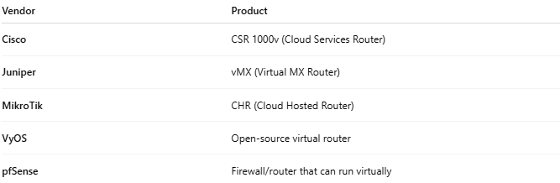

Vendor | Product
Cisco | CSR 1000v (Cloud Services Router)
Juniper | vMX (Virtual MX Router)
MikroTik | CHR (Cloud Hosted Router)
VyOS | Open-source virtual router
pfSense | Firewall/router that can run virtually

